Use Case Document
Digital Banking – Money Movement

Version: DRAFT 4.00
Date Last Published: July 7, 2020
Date Signed: Click here to enter a date.
Use Case Document Author(s):
Sunil Prashar

Contents
Document Information 4
Revision History 4
Related Document References 4
Use Case BP-UC001 - Small Business Bill Payment 5
Use Case Diagram 5
Business Requirements 8
Use Case BP-UC002 – Retail Bill Payment 10
Use Case Diagram 10
Business Requirements 13
Use Case TP-UC003 – File and Remit Business Taxes 15
Use Case Diagram 15
Business Requirements 18
Use Case TP-UC004 – Pay Personal Taxes 20
Use Case Diagram 20
Business Requirements 23
Use Case ET-UC005 – Small Business Interac E-Transfer 24
Use Case Diagram 24
E-Transfer Mock-ups 27
Add Interac e-Transfer Recipient 27
Send E-Transfer 28
Request E-Transfer 29
Auto deposit Registration 30
Business Requirements 30
Use Case ET-UC006 – Retail Interac E-Transfer 32
Use Case Diagram 32
Signature 35

Document Information

Revision History
Include signatures as part of the history
Version | Date | Authors | Revision Notes
1.00 | June 15, 2020 | Sunil Prashar | Initial draft
2.00 | June 22, 2020 | Sunil Prashar | Updated Use case diagrams and Updated Use case ET-UC005 based on use case review meeting of June 17, 2020
3.00 | July 08, 2020 | Sunil Prashar | Updated Use case UC0005 and UC0006 Interac small business and retail, added transaction limits in Business Rules section, as discussed in review meeting of July 07, 2020
3.00 | July 21, 2020 | Sunil Prashar | Updated Use case UC0004 and added BR# BRPT7.01A “File and Remit Business Taxes” through retail banking platform.

Related Document References

Ref | Document Name | Short Description and URL

Use Case BP-UC001 - Small Business Bill Payment

Use Case Diagram

Use Case ID: | BP-UC001
Use Case Name: | Digital Banking Small Business Bill Payment
Created By: | Sunil Prashar | Last Updated By:
Date Created: | June 15, 2020 | Date Last Updated: | June 22, 2020
Use Case Description: | The Small Business Digital Banking user pays one or more bills at once using CWB Digital Banking platform (Web/Mobile). Bill payments can be done immediately or they can be future-dated. There is no limit to the number of bills that can be set up under each account number.
Actors: | Digital Banking User - Primary Account Signer Or an authorized Account user with authority to pay bills using CWB Digital Banking
Pre-Conditions: | - Authorised to access CWB Digital Banking platform to make Bill Payments  - Funds are in the account available to pay bills
Post-Conditions: | A successful completion of one or more bills and confirmation of bill payment is available to view or print.
Basic Flow: | - Add a new Bill Payee: User add a new Bill Payee by searching the Bill Payee name from the pre-populated list of registered payees with CWB. User can also browse the payees by browsing from the pre-defined payee type categories such as Insurance, Property, Schools, and Utilities etc. The user needs permissions/authorization from Account signer to add a new Bill Payee.  - User enters the associated “Account Number” for the selected Bill Payee.  - Pay from Account: User select account to pay the bill from.  - Pay from Account: User can make the “Pay from” account as default by selected an account from available accounts to make bill payments if needed.  - Select “Pay to” – User select the Bill Payee to pay the bill payment.  - Payment Date – User enter the payment date to pay the bill payment, the payment date should be >= today’s date. User has ability to schedule bill pay for future date.  - Amount : User enter $Amount to pay the bill payment  - Pay Bill: User confirms the details and select “Pay Bill” to proceed with transaction  - Review (Approve or Decline) – If the transaction is initiated by delegated user or it requires additional approval then it would be pending to approve.  - System validates the details and process the transaction.  - Confirmation/Receipt – User view the Payment receipt which shows following information:  Transaction Status, Pay from, Pay to, Payment Date, Amount, Reference #
Alternative Flows: | - Select Payee: If a Bill Payee is available user skips the Step # 1.0 and 2.0 of basic flow and proceeds to Step 3.0.  - Schedule Payment – User can schedule payments for future date. User can also update or delete existing schedule bill payment(s).  - Schedule Reoccurring Payment: User can schedule reoccurring bill payments by providing Start and End date or by providing number of occurrences for the specified bill payment.  - Manage Payee- Authorized User can delete the existing Payee  - Approve/Decline – Authorized user can review the list of pending payments and can review or decline the bill payment(s)  - Recall Payment – User can recall the pending bill payment if the payment is not approved.  - Limits – Client can set their own transaction limits, which should be <= Bank’s transaction limits.
Exception: | - If the available funds < amount being paid then system generates error to notify insufficient funds for the transaction.  - The system-wide maximum bill payment amount per transaction is $1,000,000. If user want to make a payment over this amount, it is advised to split the payment into multiple payments, but do not use the same payment amount twice or it will reject as a duplicate.
Use Case Priority: | 1: High
Frequency of Use: | The frequency is dependant on user needs of Bill Payment.
Business Rules: | - The user can add or delete a new Bill Payee if the user has permissions to add or delete.  - The system-wide maximum bill payment amount per transaction is $1,000,000. If user want to make a payment over this amount, it is advised to split the payment into multiple payments, but do not use the same payment amount twice or it will reject as a duplicate.  - Client can set own transaction limits (Less than bank’s limit of $1,000,000?)  - the payment date should be >= today’s date  - For future-dated bill payments, there should be sufficient funds available in the account selected at least one business day prior to the payment date.  - The number of approvals required for transactions created by this specific user –?  - The maximum value this user can approve – ?, if the user cannot approve another user’s transactions  - When applicable, approval of a scheduled bill payment must be completed prior to the payment due date.
Assumptions: | - The system-wide maximum bill payment amount per transaction is $1,000,000. If user want to make a payment over this amount, it is advised to split the payment into multiple payments, but do not use the same payment amount twice or it will reject as a duplicate.  - Assuming it is Central 1 limitation?  - If the transaction is initiated and pending for approval, how long it can stay pending? Does it expire?
Issues and Considerations: | [List any additional issues and consideration about this use case.]

Business Requirements
ID | Requirement Description
BRBP1.00 | Ability to add a new bill payee from the list of registered billers (from list of payees) prepopulated
BRBP1.02 | Ability to make bill payments from the saved payees list
BRBP1.04 | Ability to assign/schedule a future date for bill payment instead of paying immediately. Additionally, with the possibility to set up reoccurring payments.
BRBP1.05 | Ability to set up reoccurring payments for a bill payee
BRBP1.06 | Ability to Initiate multiple bill payments to several billers added as payees to the profile.
BRBP1.07 | Ability to add a default "from account" while making a bill payment for the first time.
BRBP1.08 | Ability to view the previous transaction activity of a bill payee (transaction history of bill payee)
BRBP1.09 | Ability to edit the details of a bill payee. This would enable the user to modify the nickname and the address details of the bill payee
BRBP1.10 | Ability to delete a bill payee
BRBP1.11 | Ability to modify the details of the reoccurring payment, in case of a scheduled future-dated bill payment
BRBP1.12 | Ability to cancel the reoccurring payment, in case of a scheduled future-dated bill payment
BRBP1.15 | Ability to search for a previously added payee
BRBP1.16 | Ability to view and search from a list of recent bill payment and scheduled payments
BRBP1.17 | Manage user(delegates) privileges to add/remove bill payees
BRBP1.18 | Ability to add two factor authentication to confirm payments
BRBP1.19 | Ability to approve/decline pending bill payment(s)
BRBP1.20 | Ability to Preview a bill payment before commit
BRBP1.21 | Ability to recall a pending bill payment that has not been approved
BRBP1.22 | Ability to validate payee requirements when adding new payee (ex. Account number format)
BRBP1.23 | Ability to add notes to a bill payment transaction
BRBP1.24 | Ability view payment confirmation
BRBP1.25 | Ability print payment confirmation
BRBP1.26 | CWB must have ability to maintain a list of payees (Need more details of Backend process)
BRBP1.27 | Ability to set transaction limit at different levels - bank, client, user, transaction type
BRBP1.29 | Ability to filter transaction based on Bill payment type
BRBP1.30 | Ability for clients to set own Bill Payment limit based on preferences. The limit must be less than or equal to the limit set at the bank level for specific transaction type
BRBP1.31 | Ability to view transaction fee prior to committing the transaction – Not in current state of MDSB?

Use Case BP-UC002 – Retail Bill Payment

Use Case Diagram

Use Case ID: | BP-UC002
Use Case Name: | Digital Banking Retail Bill Payment
Created By: | Sunil Prashar | Last Updated By:
Date Created: | June 15, 2020 | Date Last Updated:
Use Case Description: | The Retail banking user pays one or more bills at once using CWB Digital Banking platform (Web/Mobile). Bill payments can be done immediately or they can be future-dated. There is no limit to the number of bills that can be set up under each account number.
Actors: | CWB Digital Banking Retail User
Pre-Conditions: | - Authorized to access CWB Digital Banking platform to make Bill Payments  - Funds available to pay bills
Post-Conditions: | A successful completion of one or more bills and confirmation of bill payment is available to view or print.
Basic Flow: | - Add a new Bill Payee: User adds a new Bill Payee by searching the Bill Payee name from the pre-populated list of registered payees with CWB. User can also browse the payees by browsing from the pre-defined payee type categories such as Insurance, Property, Schools, and Utilities etc.  - User enters the associated “Account Number” for the selected Bill Payee.  - Pay from Account: User select account to pay the bill from.  - Pay from Account: User can make the “Pay from” account as default by selected an account from available accounts to make bill payments if needed.  - Select “Pay to” – User select the Bill Payee to pay the bill payment.  - Payment Date – User enter the payment date to pay the bill payment, the payment date should be >= today’s date. User has ability to schedule bill pay for future date.  - Amount : User enter $Amount to pay the bill payment  - Pay Bill: User confirms the details and select “Pay Bill” to proceed with transaction  - System validates the details and process the transaction.  - Confirmation/Receipt – User view the Payment receipt which shows following information:  Transaction Status, Pay from, Pay to, Payment Date, Amount, Reference #
Alternative Flows: | - Select Payee: If a Bill Payee is available user skips the step # 1.0 of basic flow and proceeds to Step 2.0.  - Schedule Payment – User can schedule payments for future date. User can also update or delete existing scheduled bill payment(s).  - Schedule Reoccurring Payment: User can schedule reoccurring bill payments by providing Start and End date or by providing number of occurrences for the specified bill payment.  - Manage Payee- User can delete the existing Payee
Exception: | - If the available funds < amount being paid then system generates error to notify insufficient funds for the transaction.  - The system-wide maximum bill payment amount per transaction is $1,000,000. If user want to make a payment over this amount, it is advised to split the payment into multiple payments, but do not use the same payment amount twice or it will reject as a duplicate.
Use Case Priority: | 1: High
Frequency of Use: | The frequency is dependant on user needs of bill payment
Business Rules: | - The system-wide maximum bill payment amount per transaction is $1,000,000. If user want to make a payment over this amount, it is advised to split the payment into multiple payments, but do not use the same payment amount twice or it will reject as a duplicate.  - The payment date should be >= today’s date.  - For future-dated bill payments, there should be sufficient funds available in the account selected at least one business day prior to the payment date.
Assumptions: | - The system-wide maximum bill payment amount per transaction is $1,000,000. If user want to make a payment over this amount, it is advised to split the payment into multiple payments, but do not use the same payment amount twice or it will reject as a duplicate.  - Assuming it is Central 1 limitation?
Issues and Considerations: | [List any additional issues and consideration about this use case.]

Business Requirements
ID | Requirement Description
BRBP1.00 | Ability to add a new bill payee from the list of registered billers (from list of payees) prepopulated
BRBP1.02 | Ability to make bill payments from the saved payees list
BRBP1.04 | Ability to assign/schedule a future date for bill payment instead of paying immediately. Additionally, with the possibility to set up reoccurring payments.
BRBP1.05 | Ability to set up reoccurring payments for a bill payee
BRBP1.06 | Ability to Initiate multiple bill payments to several billers added as payees to the profile.
BRBP1.07 | Ability to add a default "from account" while making a bill payment for the first time.
BRBP1.08 | Ability to view the previous transaction activity of a bill payee (transaction history of bill payee)
BRBP1.09 | Ability to edit the details of a bill payee. This would enable the user to modify the nickname and the address details of the bill payee
BRBP1.10 | Ability to delete a bill payee
BRBP1.11 | Ability to modify the details of the reoccurring payment, in case of a scheduled future-dated bill payment
BRBP1.12 | Ability to cancel the reoccurring payment, in case of a scheduled future-dated bill payment
BRBP1.15 | Ability to search for a previously added payee
BRBP1.16 | Ability to view and search from a list of recent bill payment and scheduled payments
BRBP1.18 | Ability to add two factor authentication to confirm payments
BRBP1.20 | Ability to Preview a bill payment before commit
BRBP1.22 | Ability to validate payee requirements when adding new payee (ex. Account number format)
BRBP1.23 | Ability to add notes to a bill payment transaction
BRBP1.24 | Ability view payment confirmation
BRBP1.25 | Ability print payment confirmation
BRBP1.26 | CWB must have ability to maintain a list of payees (Need more details of backend process)
BRBP1.27 | Ability to set transaction limit at different levels - bank, client, user, transaction type
BRBP1.29 | Ability to filter transaction based on Bill payment type
BRBP1.30 | Ability for clients to set own Bill Payment limit based on preferences. The limit must be less than or equal to the limit set at the bank level for specific transaction type
BRBP1.31 | Ability to view transaction fee prior to committing the transaction – Not in current state of MDI?

Use Case TP-UC003 – File and Remit Business Taxes

Use Case Diagram

Use Case ID: | TP-UC003
Use Case Name: | Digital Banking Small Business – File and Remit Business Taxes
Created By: | Sunil Prashar | Last Updated By:
Date Created: | June 15, 2020 | Date Last Updated: | June 19, 2020
Use Case Description: | The Small Business Digital Banking user files and remits business taxes (Federal and Provincial) using CWB Digital Banking platform (Web/Mobile).
Actors: | Digital Banking User - Primary Account Signer Or an authorized Account user with authority to file and remit taxes using CWB Digital Banking.
Pre-Conditions: | - Authorised to access CWB Digital Banking platform to file and remit business taxes  - Funds are in the account available to remit taxes  - Information required to file business taxes is available
Post-Conditions: | A successful completion of one or more tax remittances is available to view or print.
Basic Flow: | - Add a Tax Payee: User adds a new Tax Payee by searching the Tax Payee name from the pre-populated list. User can also browse the payees by browsing from the pre-defined payee type categories such as Federal taxes or Provincial taxes etc. The user needs permissions/authorization from Account Signer to add a new Tax Payee.  - User enters the required information to file based on the tax type selected. (Note: Data / Information collection requirements varies based on the selected Tax Payee e.g. GST, Payroll Contribution, Corporation Income Tax etc.)  - Pay from Account: User select account to pay the Taxes from.  - Pay from Account: User can make the “Pay from” account as default by selected an account from available accounts to remit tax payments if needed.  - Select “Pay to” – User select the Tax Payee to file and remit taxes.  - Payment Date – User enter the payment date to remit the payment, the payment date should be >= today’s date. User has ability to schedule tax remittance for future date.  - Amount : User enter $Amount to remit the tax payment  - File and Remit: User confirms the details of Tax file and proceeds with remittance transaction.  - Review (Approve or Decline) – If the transaction requires additional approval then it would be pending to approve. Approver approves the transaction.  - System validates the details and process the transaction.  - Confirmation/Receipt – User view the confirmation of Tax filing and remittance receipt
Alternative Flows: | - Select Payee: If a Tax Payee is available user skips the step # 1.0 of basic flow and proceeds to Step 2.0.  - Schedule Payment – User can schedule remittance for future date. User can also update or delete existing scheduled payment(s).  - Schedule Reoccurring Payment: User can schedule reoccurring tax payments by providing Start and End date or by providing number of occurrences for the specified tax payment.  - Manage Payee- Authorized User can delete the existing Tax Payee.  - Approve/Decline – Authorized user can review the list of pending tax payments and can review or decline the tax payment(s).  - Recall Payment – User can recall the pending tax payment if it is not approved.
Exception: | - If the available funds < amount being paid then system generates error to notify insufficient funds for the transaction.  - The system-wide maximum bill payment amount per transaction is $1,000,000. If user want to make a payment over this amount, it is advised to split the payment into multiple payments, but do not use the same payment amount twice or it will reject as a duplicate. – Need to confirm if this rule applies to Taxes?
Use Case Priority: | 1: High
Frequency of Use: | The frequency is dependant on user needs of Bill Payment.
Business Rules: | - Delegated user can add a new Tax Payee if the user has permissions to add.  - The system-wide maximum tax payment amount per transaction is $1,000,000. If user want to make a payment over this amount, it is advised to split the payment into multiple payments, but do not use the same payment amount twice or it will reject as a duplicate. – Need to confirm if this rule applies to Taxes?  - Client can set own transaction limits (Less than bank’s limit)  - the payment date should be >= today’s date  - For future-dated Tax payments, there should be sufficient funds available in the account selected at least one business day prior to the payment date.  - The number of approvals required for transactions created by this specific user –?  - The maximum value this user can approve – ?, if the user can approve another user’s transactions  - When applicable, approval of a scheduled tax payment must be completed prior to the payment due date.  - User can view the history based on selected period (Start date and End date)
Assumptions: | - The required form for Tax filling are implemented (Federal and Provincial Multiple forms)  - The system-wide maximum bill payment amount per transaction is $1,000,000. If user want to make a payment over this amount, it is advised to split the payment into multiple payments, but do not use the same payment amount twice or it will reject as a duplicate.  - Assuming it is Central 1 limitation?
Issues and Considerations: | Currently, System does not provide ability to only remit business taxes. User has to file taxes along with remittance. Some business user may only like to remit taxes rather than filing through CWB digital platform. – See comments in the beginning of use case diagram

Business Requirements
ID | Requirement Description
BRTP6.00 | Ability to add Federal Tax Types as Payees from pre-populated list
BRTP6.01 | Ability to file remit to Federal Tax Types
BRTP6.02 | Ability to add Provincial Tax types as Payees from pre-populated list
BRTP6.03 | Ability to file and remit to Provincial Tax Types
BRTP6.06 | Ability to view filling and remittance history
BRTP6.07 | Ability to delete tax payees
BRTP6.08 | Ability to modify tax payees
BRTP6.10 | Ability to schedule a tax remittance
BRTP6.11 | Ability to set up reoccurring tax payments
BRTP6.12 | Ability to modify reoccurring tax payments
BRTP6.13 | Ability to remit taxes from a default account
BRTP6.14 | Manage user(delegates) privileges to add/remove tax payees
BRTP6.15 | Ability to add two factor authentication to confirm payments
BRTP6.16 | Ability to approve/decline pending tax payment(s)
BRTP6.17 | Ability to Preview a tax payment before commit
BRTP6.18 | Ability to recall a pending tax payment that has not been approved
BRTP6.19 | Ability to validate payee data requirements when adding new payee (ex. Account number format)
BRTP6.20 | Ability to search for a previously added tax payee
BRTP6.21 | Ability to view and search from a list of recent tax payment and scheduled payments
BRTP6.22 | Ability to set up direct deposit with CRA by providing required information such as company name, CRA Business number or Payroll Account number and a valid CWB bank account that a user will like the deposit to go into and Corporation officer information(First and Last name – Mandatory, Date of Birth and SIN optional)

Use Case TP-UC004 – Pay Personal Taxes

Use Case Diagram

Use Case ID: | TP-UC004
Use Case Name: | Digital Banking Retail – Pay Personal Taxes
Created By: | Sunil Prashar | Last Updated By:
Date Created: | June 15, 2020 | Date Last Updated: | June 16, 2020
Use Case Description: | CWB Digital banking retail client make payments for personal taxes using CWB Digital Banking platform (Web/Mobile).
Actors: | Client / CWB Digital Banking Retail User
Pre-Conditions: | - Authorised to access CWB Digital Banking platform to pay taxes  - Funds are in the account available to pay taxes  - Information required to pay taxes is available
Post-Conditions: | A successful completion of one or more tax remittances is available to view or print.
Basic Flow: | - Add a Tax Payee: User add a new Tax Payee by searching the Tax Payee name from the pre-populated list. User can also browse the payees by browsing from the pre-defined payee type categories such as Federal taxes or Provincial taxes etc.  - User enters the required information to file based on the tax type selected. (Note: Data / Information collection requirements varies based on the selected Tax Payee e.g. Income Tax, etc.)  - Pay from Account: User select account to pay the Taxes from.  - Pay from Account: User can make the “Pay from” account as default by selected an account from available accounts to remit tax payments if needed.  - Select “Pay to” – User select the Tax Payee to remit taxes.  - Payment Date – User enter the payment date to remit the payment, the payment date should be >= today’s date. User has ability to schedule tax remittance for future date.  - Amount : User enter $Amount to remit the tax payment  - Remit: User confirms the details of tax remittance and proceeds with remittance transaction.  - System validates the details and process the transaction.  - Confirmation/Receipt – User view the confirmation of Tax filing and remittance receipt.
Alternative Flows: | - Select Payee: If a Tax Payee is available user skips the step # 1.0 of basic flow and proceeds to Step 2.0.  - Schedule Payment – User can schedule remittance for future date. User can also update or delete existing scheduled payment(s).  - Schedule Reoccurring Payment: User can schedule reoccurring tax payments by providing Start and End date or by providing number of occurrences for the specified tax payment.  - Manage Payee- User can delete the existing Payee.
Exception: | - If the available funds < amount being paid then system generates error to notify insufficient funds for the transaction.  - The system-wide maximum bill payment amount per transaction is $1,000,000. If user want to make a payment over this amount, it is advised to split the payment into multiple payments, but do not use the same payment amount twice or it will reject as a duplicate. – Need to confirm if this rule applies to Taxes?
Use Case Priority: | 1: High
Frequency of Use: | The frequency is dependant on user needs of Bill Payment.
Business Rules: | - The system-wide maximum tax payment amount per transaction is $1,000,000. If user want to make a payment over this amount, it is advised to split the payment into multiple payments, but do not use the same payment amount twice or it will reject as a duplicate. – Need to confirm if this rule applies to Taxes?  - Client can set own transaction limits (Less than bank’s limit of $1,000,000?)  - the payment date should be >= today’s date  - For future-dated Tax payments, there should be sufficient funds available in the account selected at least one business day prior to the payment date.  - When applicable, approval of a scheduled tax payment must be completed prior to the payment due date.  - User can view the tax payment history based on selected period (Start date and End date)  - Retail Banking client should also have ability to file and remit business taxes as defined in use case TP-UC0003 as well.
Assumptions: | - The required form for Tax payments are implemented  - The system-wide maximum bill payment amount per transaction is $1,000,000. If user want to make a payment over this amount, it is advised to split the payment into multiple payments, but do not use the same payment amount twice or it will reject as a duplicate.  - Assuming it is Central 1 limitation?
Issues and Considerations:

Business Requirements
ID | Requirement Description
BRPT7.01 | Ability to pay personal taxes
BRPT7.01A | Ability to file and remit business taxes as defined in use case TP-UC0003 through retail banking platform.
BRPT7.02 | Ability to add Tax Payees from pre-populated list
BRPT7.03 | Ability to view tax remittance history
BRPT7.04 | Ability to delete tax payees
BRPT7.05 | Ability to modify tax payees
BRPT7.06 | Ability to schedule a tax remittance
BRPT7.07 | Ability to set up reoccurring tax payments
BRPT7.08 | Ability to modify reoccurring tax payments
BRPT7.09 | Ability to remit taxes from a default account
BRPT7.10 | Manage user – Ability to remove tax payees
BRPT7.11 | Ability to add two factor authentication to confirm payments
BRPT7.12 | Ability to Preview a tax payment before commit
BRPT7.13 | Ability to recall a pending tax payment that has not been approved
BRPT7.14 | Ability to validate payee data requirements when adding new payee (ex. Account number format)
BRPT7.15 | Ability to search for a previously added tax payee
BRPT7.16 | Ability to view and search from a list of recent tax payment and scheduled payments
BRPT7.17 | Ability to set up direct deposit with CRA by providing required information such as First Name, Last Name, Date of Birth (DOB), and Social Insurance Number (SIN).

Use Case ET-UC005 – Small Business Interac E-Transfer

Use Case Diagram

Use Case ID: | ET-UC005
Use Case Name: | Digital Banking Small Interac E-transfer
Created By: | Sunil Prashar | Last Updated By: | Sunil Prashar
Date Created: | June 15, 2020 | Date Last Updated: | June 20, 2020
Use Case Description: | The Digital Banking Small Business user send or receive money through E-transfer using CWB Digital Banking platform (Web/Mobile). E-transfer payments can be done immediately or they can be future-dated.
Actors: | Digital Banking User - Primary Account Signer  Digital Banking User – An authorized Account user with authority to use E-transfer using CWB Digital Banking
Pre-Conditions: | - User is authorised to access CWB Digital Banking platform to use E-transfer  - CWB Digital platform is supported by Interac Email Transfer
Post-Conditions: | A successful completion of send or receive money using E-transfer.
Basic Flow: | - Add a new recipient to send money: Authorised User add a new recipient by entering details as following:  Name of the recipient, Contact Method (Email address or Mobile number)  - Pay from Account: User select account to make the e-transfer from.  - Pay from Account: User can make the “Pay from” account as default by selected an account from available accounts to make e-transfer if needed.  - Select “Pay to” – User select the recipient to send the e-transfer.  - Date – User enter the optional date to e-transfer payment, the payment date should be >= today’s date. User can schedule the e-transfer for future date.  - Amount: User enter $Amount of e-transfer (there is a daily/weekly limit of e-transfer). (Ability to set limit by client)  - Security question: User can setup security question and answer for the recipient to verify transaction when receiving the money.  - User confirms the details and select “Submit” to proceed with transaction.  - Review (Approve or Decline) – If requires additional approval then transaction would be pending to approve. Authorised user approves the transaction.  - System validates the details and process the transaction.  - Confirmation/Receipt – User view the confirmation of e-transfer.  - Recipient receives the notification of transfer through contact method selected (Email or Mobile phone).  - E-Transfer completed.
Alternative Flows: | - Select Payee: If a Payee is available user skips the Step # 1.0 of basic flow and proceeds to Step 2.0.  - Review – Decline Transaction: At Step 9, If user decline the transaction then system does not proceed with next step 10.0 and transaction status shows declined.  - Auto deposit: User can opt-in for Auto deposit feature, in this case user is recipient of the e-transfer then the money will auto deposit into the bank account without security question verification.  - Schedule Payment – User can schedule E-transfer for future date. User can also update or delete existing schedule E-transfer(s).  - Schedule Reoccurring Payment: User can schedule reoccurring E-transfer(s) by providing Start and End date or by providing number of occurrences for the specified E-transfer.  - Manage Payee- Authorized User can update or delete the existing recipient  - Recall Payment – User can recall the pending E-transfer if the payment is not approved or processed.  - Fees? – Warning message  - Limits – Systems display available limits of e-transfers (daily / weekly)  - Client Limit – Client can set their own transaction limit < = Bank’s Limit  - Re use Security question and answer – masked, disable for higher value. System provides ability to re-use security question for the transaction.
Exception: | - If the available funds < amount being paid then system generates error to notify insufficient funds for the transaction.  - System do not proceed with transactions value > transaction limits.
Use Case Priority: | 1: High
Frequency of Use: | The frequency is dependant on user needs of E-transfer.
Business Rules: | - If user is the sender, an E-Transfer will be returned to user’s account:  - if the recipient does not claim the E-Transfer within 30 days of the date the E-Transfer is initiated;  - if the E-Transfer cannot be successfully sent to the recipient’s electronic address as provided by user; or  - If the recipient declines the E-Transfer.  Transaction limits  Outgoing (CWB send limits):  o Business:  - 24 hour rolling limit of $10,000  - Weekly rolling limit of $70,000  - Monthly rolling limit of $300,000; the rolling limit for weekly is 7 days, and monthly is 30 days  Incoming (CWB receive limits):  - 24 hour rolling limit of $10,000  - Daily cumulative limit of $10,000  - 7-Day rolling transaction limit of $70,000  - 30-Day rolling transaction limit of $300,000  Example for 24 hour rolling limit: If I send from my account $9500 in EMT’s at 10 am on June 29th, I only have at most $500 remaining until “10:01” am the next day, June 30th. Any attempts greater than $500 the client would get the “exceeded limit” response. Limits do not get reset after midnight.  - User can add a new recipient if the user has permissions to add.  - The payment date should be >= today’s date  - For future-dated e-transfers, there should be sufficient funds available in the account selected at least one business day prior to the payment date.  - The number of approvals required for transactions created by this specific user –?  - The maximum value this user can approve – ?, if the user can approve another user’s transactions  - When applicable, approval of a scheduled E-transfer must be completed prior to the payment due date. The payment would be expired and system should send alert :  - With in X number of days of due date  - When the payment is expired
Assumptions: | - Interac is the service provider for E-Transfers
Issues and Considerations: | Can user use bulk e-transfers? – Future - Pending C1 / vendor Confirmation  - C1 didn’t build out the functionality for bulk eTransfers. (Gerry Weber)

E-Transfer Mock-ups
The following screenshots are being taken from current system and can be used for reference purpose:

Add Interac e-Transfer Recipient

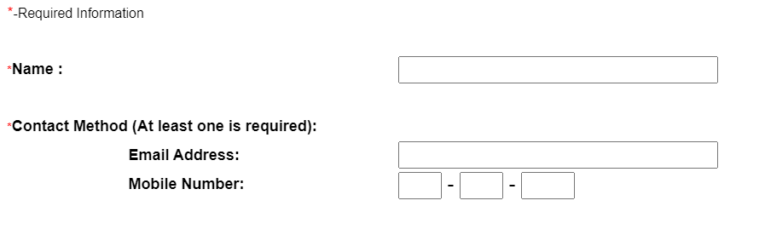

Send E-Transfer
From* : < From Account >
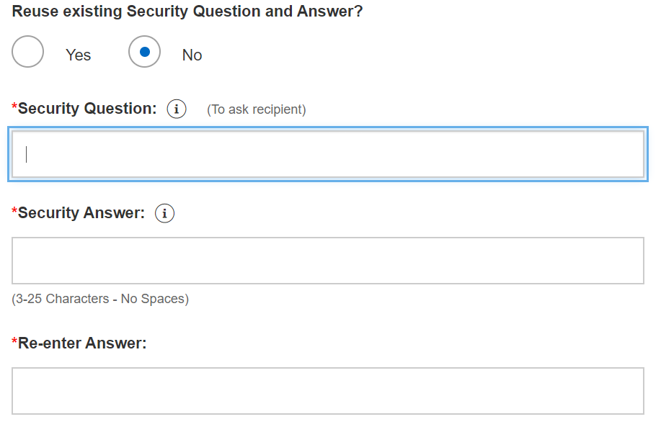
Amount*:
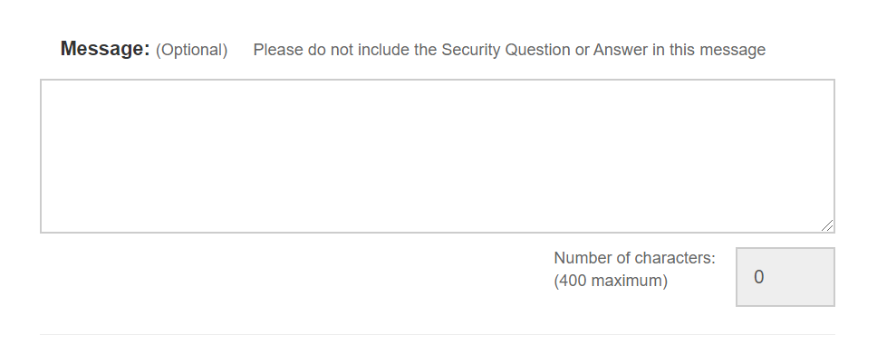
Confirm
Cancel

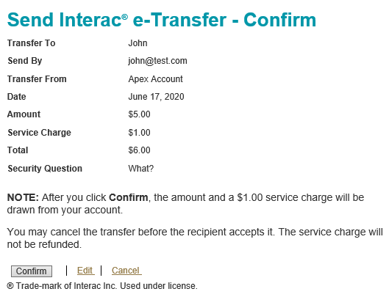

Request E-Transfer

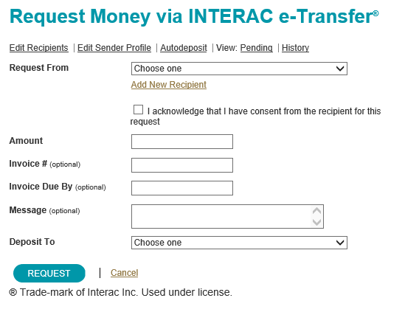

Auto deposit Registration
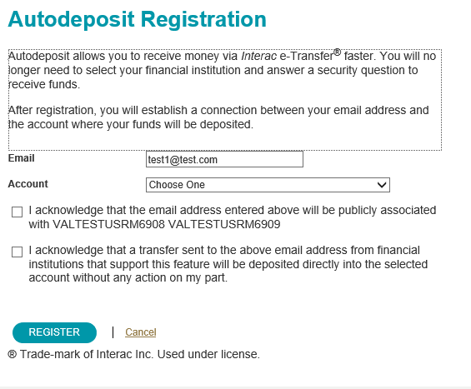

Business Requirements
ID |  | Requirement Description
BRET3.00 | Ability to create sender profile
BRET3.01 | Ability to create recipient profile
BRET3.02 | Ability to modify the details of a recipient.
BRET3.03 | Ability to delete a recipient
BRET3.04 | Ability to view list of recipient
BRET3.05 | Ability to view recipient details
BRET3.06 | Ability to set up Auto deposit on profile
BRET3.07 | Ability to remove Auto deposit on profile
BRET3.08 | Ability to search past transfers
BRET3.09 | Ability to review past transfers details
BRET3.10 | Ability to choose which CWB account to transfer from
BRET3.11 | Ability to choose which recipient to sent the transfer to
BRET3.12 | Ability to request E-transfer through Email or Mobile text
BRET3.13 | Ability to send E-transfer through Email or Mobile text
BRET3.14 | Ability to schedule E-transfer
BRET3.15 | Ability to set up reoccurring E-transfer
BRET3.16 | Ability to modify reoccurring E-transfer
BRET3.17 | Ability to cancel scheduled or reoccurring E-transfer

Use Case ET-UC006 – Retail Interac E-Transfer

Use Case Diagram

Use Case ID: | ET-UC006
Use Case Name: | Digital Banking Retail Interac E-transfer
Created By: | Sunil Prashar | Last Updated By: | Sunil Prashar
Date Created: | June 29, 2020 | Date Last Updated: | June 29, 2020
Use Case Description: | The Digital Banking Small Business user send or receive money through E-transfer using CWB Digital Banking platform (Web/Mobile). E-transfer payments can be done immediately or they can be future-dated.
Actors: | Digital Banking Retail User
Pre-Conditions: | - User is authorised to access CWB Digital Banking platform to use E-transfer  - CWB Digital platform is supported by Interac Email Transfer
Post-Conditions: | A successful completion of send or receive money using E-transfer.
Basic Flow: | - Add a new recipient to send money: User adds a new recipient by entering details as following:  Name of the recipient, Contact Method (Email address or Mobile number)  - Pay from Account: User select account to make the e-transfer from.  - Pay from Account: User can make the “Pay from” account as default by selected an account from available accounts to make e-transfer if needed.  - Select “Pay to” – User select the recipient to send the e-transfer.  - Date – User enter the optional date to e-transfer payment, the payment date should be >= today’s date. User can schedule the e-transfer for future date.  - Amount: User enter $Amount of e-transfer (there is a daily/weekly limit of e-transfer). (Ability to set limit by client)  - Security question: User can setup security question and answer for the recipient to verify transaction when receiving the money.  - User confirms the details and select “Submit” to proceed with transaction.  - System validates the details and process the transaction.  - Confirmation/Receipt – User view the confirmation of e-transfer.  - Recipient receives the notification of transfer through contact method selected (Email or Mobile phone).  - E-Transfer completed.
Alternative Flows: | - Select Payee: If a Payee is available user skips the Step # 1.0 of basic flow and proceeds to Step 2.0.  - Auto deposit: User can opt-in for Auto deposit feature, in this case user is recipient of the e-transfer then the money will auto deposit into the bank account without security question verification.  - Schedule Payment – User can schedule E-transfer for future date. User can also update or delete existing schedule E-transfer(s).  - Schedule Reoccurring Payment: User can schedule reoccurring E-transfer(s) by providing Start and End date or by providing number of occurrences for the specified E-transfer.  - Manage Payee- User can update or delete the existing recipient  - Recall Payment – User can recall the pending E-transfer if the payment is not processed.  - Fees? – Warning message  - Limits – Systems display available limits of e-transfers (daily / weekly)  - Client Limit – Client can set their own transaction limit < = Bank’s Limit  - Re use Security question and answer – masked, disable for higher value. System provides ability to re-use security question for the transaction.
Exception: | - If the available funds < amount being paid then system generates error to notify insufficient funds for the transaction.  - System do not proceed with transactions value > transaction limits.
Use Case Priority: | 1: High
Frequency of Use: | The frequency is dependant on user needs of E-transfer.
Business Rules: | - If user is the sender, an E-Transfer will be returned to user’s account:  - if the recipient does not claim the E-Transfer within 30 days of the date the E-Transfer is initiated;  - if the E-Transfer cannot be successfully sent to the recipient’s electronic address as provided by user; or  - If the recipient declines the E-Transfer.  - User can add a new recipient if the user has permissions to add.  - The payment date should be >= today’s date  - For future-dated e-transfers, there should be sufficient funds available in the account selected at least one business day prior to the payment date.  - The number of approvals required for transactions created by this specific user –?  - The maximum value this user can approve – ?, if the user can approve another user’s transactions  - When applicable, approval of a scheduled E-transfer must be completed prior to the payment due date. The payment would be expired and system should send alert :  - With in X number of days of due date  - When the payment is expired  Transaction Limits  Retail:  Outgoing:  - Maximum Transaction limit of $3,000  - Daily Transaction limit of $10,000  - Weekly rolling limit of $10,000.  - Monthly rolling limit of $20,000; the rolling limit for weekly is 7 days, and monthly is 30 days. The rolling day is on a 24 hour clock for the limits to reset.  Incoming:  Incoming (CWB receive limits):  - 24 hour rolling limit of $10,000  - Daily cumulative limit of $10,000  - 7-Day rolling transaction limit of $70,000  - 30-Day rolling transaction limit of $300,000
Assumptions: | - Interac is the service provider for E-Transfers
Issues and Considerations:

Signature
This section contains the signatures of the primary key stakeholders indicating acknowledgement and acceptance that the information collected in this document represents the interests of all business area stakeholders listed in the Stakeholder section.
Role | Name & Title | Date | Digitally Approved
☐
Add to history that doc was digitally approved
☒
Add to history that doc was digitally approved
☐
Add to history that doc was digitally approved

